INTERNET PROGRAMMING LAB
Hospital Appointment Booking

Aim
To design and develop a Hospital Appointment Booking system for patients, hospitals and the administrator, with doctor search, appointment booking, check-in form, reviews and map links.

Technologies Used
- HTML5 - page structure and forms
- CSS3 - responsive layout and styling
- JavaScript (ES6) - client-side logic, validation and role-based access
- Browser localStorage - data storage (no server needed)

Modules and Functionalities
Admin
- Manage Doctors
- Manage Appointments
- Hospitals
- Ratings
- Statistics
- My Profile
Patient
- Search Hospitals / Map
- Search Doctors & Book
- My Appointments
- Check-in Form
- Rate Doctor
- My Profile
Hospital
- Hospital Details
- Doctors
- Appointments
- My Profile

Business Rules Implemented
- Double booking of the same doctor, date and time is prevented.
- Hospital location opens in Google Maps.
- Hospitals can manage their own doctor and appointment details.

Algorithm / Procedure
- Open the HTML file in a web browser; the login page is displayed.
- Log in with an existing account, or register a new user (Register button).
- On login, the menu for that role is built from the role-page configuration.
- Each page reads and writes records through the common save() routine, which runs the validation rules and updates stock/amount.
- Tables are rendered from the stored records; search and filter options refine the list.
- Logout clears the session and returns to the login page.

Demo Login Details
Role | Username | Password
Admin | admin | admin123
Patient | patient | patient123
Hospital | hospital | hospital123

Source Code
File: 08_hospital_appointment.html
<!DOCTYPE html>
<html lang="en">
<head>
<meta charset="utf-8" />
<meta name="viewport" content="width=device-width,initial-scale=1" />
<title>Hospital Appointment Booking</title>
<style>
:root {
--c: #138d75;
}
* {
box-sizing: border-box;
}
body {
margin: 0;
font-family: system-ui, Arial, sans-serif;
background: #f4f6fa;
color: #222;
}
header {
background: var(--c);
color: #fff;
padding: 12px 20px;
display: flex;
flex-wrap: wrap;
gap: 10px;
align-items: center;
justify-content: space-between;
}
header h1 {
font-size: 1.2rem;
margin: 0;
}
nav {
display: flex;
flex-wrap: wrap;
gap: 6px;
align-items: center;
}
nav button {
background: #fff;
color: var(--c);
border: 0;
border-radius: 6px;
padding: 7px 12px;
cursor: pointer;
font-size: 0.88rem;
}
.b {
background: var(--c);
color: #fff;
border: 0;
border-radius: 6px;
padding: 7px 12px;
cursor: pointer;
margin: 2px;
font-size: 0.88rem;
}
.b.r {
background: #c0392b;
}
main {
max-width: 1150px;
margin: 20px auto;
padding: 0 14px;
}
.card {
background: #fff;
border-radius: 10px;
padding: 16px;
margin: 12px 0;
box-shadow: 0 1px 4px #0002;
}
label {
display: block;
font-size: 0.85rem;
margin: 8px 0 3px;
}
input,
select {
width: 100%;
padding: 8px;
border: 1px solid #bbb;
border-radius: 6px;
font: inherit;
}
.g {
display: grid;
grid-template-columns: repeat(auto-fit, minmax(210px, 1fr));
gap: 0 14px;
}
table {
width: 100%;
border-collapse: collapse;
background: #fff;
}
th,
td {
padding: 8px;
border-bottom: 1px solid #e3e3e3;
text-align: left;
font-size: 0.86rem;
}
th {
background: #eef1f6;
}
.tw {
overflow-x: auto;
}
.s {
display: flex;
gap: 8px;
flex-wrap: wrap;
align-items: center;
}
.s input,
.s select {
width: auto;
flex: 1;
min-width: 140px;
}
.stat {
display: inline-block;
background: #fff;
border-left: 5px solid var(--c);
padding: 12px 20px;
margin: 6px;
border-radius: 8px;
box-shadow: 0 1px 4px #0002;
}
.stat b {
font-size: 1.5rem;
display: block;
}
a {
color: var(--c);
}
small {
color: #666;
}
</style>
</head>
<body>
<header>
<h1>🏥 Hospital Appointment Booking</h1>
<nav id="nav"></nav>
</header>
<main id="main"></main>
<footer style="text-align: center; padding: 20px">
<small
>Demo app - data is stored in your browser (localStorage) -
<a
href="#"
onclick="
resetDemo();
return false;
"
>reset demo data</a
></small
>
</footer>
<script>
const A = {
id: "exp8",
t: "Hospital Appointment Booking",
roles: { Admin: { reg: 0 }, Patient: { reg: 1 }, Hospital: { reg: 1 } },
ent: {
Hospitals: "name,location,phone,mapLink~:map",
Doctors:
"name,specialty,hospital:ref:Hospitals.name,fee:number,available:select:Mon-Fri|Mon-Sat|Weekends",
Appointments:
"doctor:ref:Doctors.name,date:date,time:select:9AM|10AM|11AM|2PM|4PM,hospital~,patient~,status~:select:Booked|Cancelled|Visited",
CheckIn: "symptoms,notes?",
Reviews: "doctor:ref:Doctors.name,rating:select:5|4|3|2|1,comment",
},
seed: {
Hospitals:
"MedCare Hospital|Chennai|044-24681357|MedCare Hospital Chennai;City Care Clinic|Coimbatore|0422-2345678|City Care Clinic Coimbatore",
Doctors:
"Dr. Priya Raman|Cardiology|MedCare Hospital|600|Mon-Sat;Dr. Arun Kumar|Orthopedics|MedCare Hospital|500|Mon-Fri;Dr. Meena Iyer|Pediatrics|City Care Clinic|400|Mon-Sat",
},
pages: {
Admin: [
["Manage Doctors", "crud", "Doctors"],
["Manage Appointments", "crud", "Appointments"],
["Hospitals", "crud", "Hospitals"],
["Ratings", "crud", "Reviews"],
["Statistics", "report", ""],
],
Patient: [
["Search Hospitals / Map", "browse", "Hospitals", { find: "name,location" }],
[
"Search Doctors & Book",
"browse",
"Doctors",
{
find: "name,specialty,hospital",
flt: "specialty",
acts: [["Book Appointment", "Appointments", { doctor: "name" }]],
},
],
[
"My Appointments",
"mine",
"Appointments",
{ sets: [["Cancel", { status: "Cancelled" }, "status", "Cancelled"]] },
],
["Check-in Form", "add", "CheckIn", {}],
["Rate Doctor", "add", "Reviews", {}],
],
Hospital: [
["Hospital Details", "crud", "Hospitals"],
["Doctors", "crud", "Doctors"],
["Appointments", "crud", "Appointments"],
],
},
inv: {},
own: {},
};
const P = A.id + "_",
$ = (i) => document.getElementById(i);
const mem = {},
LS = (() => {
try {
localStorage.setItem("_t", 1);
localStorage.removeItem("_t");
const l = localStorage;
return {
getItem: (k) => l.getItem(k),
setItem: (k, v) => l.setItem(k, v),
removeItem: (k) => l.removeItem(k),
keys: () => Object.keys(l),
};
} catch (e) {
return {
getItem: (k) => mem[k] ?? null,
setItem: (k, v) => {
mem[k] = String(v);
},
removeItem: (k) => {
delete mem[k];
},
keys: () => Object.keys(mem),
};
}
})();
const SS = {
get: (k) => {
try {
return sessionStorage.getItem(k) || mem["s" + k];
} catch (e) {
return mem["s" + k];
}
},
set: (k, v) => {
mem["s" + k] = v;
try {
sessionStorage.setItem(k, v);
} catch (e) {}
},
del: (k) => {
delete mem["s" + k];
try {
sessionStorage.removeItem(k);
} catch (e) {}
},
};
const L = (s) => JSON.parse(LS.getItem(P + s) || "[]"),
W = (s, v) => LS.setItem(P + s, JSON.stringify(v));
const today = () => new Date().toISOString().slice(0, 10),
add = (d, n) => {
const x = new Date(d);
x.setDate(x.getDate() + n);
return x.toISOString().slice(0, 10);
},
diff = (a, b) => Math.round((new Date(b) - new Date(a)) / 864e5);
const uid = () => Date.now().toString(36) + Math.random().toString(36).slice(2, 6);
const lab = (k) => k.replace(/([A-Z])/g, " $1").replace(/^./, (c) => c.toUpperCase());
const E = (s) =>
String(s ?? "").replace(
/[&<>"]/g,
(c) => ({ "&": "&amp;", "<": "&lt;", ">": "&gt;", '"': "&quot;" })[c],
);
const FS = (s) =>
s.split(",").map((x) => {
let [k, t = "text", ...o] = x.split(":");
const auto = k.endsWith("~"),
opt = auto || k.endsWith("?");
k = k.replace(/[~?]$/, "");
return { k, t, auto, opt, o: o.join(":").split("|") };
});
let act = [];
const R = (f) => act.push(f) - 1;
const me = () => L("Users").find((u) => u.id == SS.get(P + "me"));
const roles = Object.keys(A.roles),
adm = roles[0],
slug = (r) => r.toLowerCase().replace(/\W/g, "");
const M = (h) => {
$("main").innerHTML = h;
};
const HK = {},
CALC = {};
let BD = () => "";

Object.assign(HK, {
Hospitals: (v) => {
v.mapLink = v.name + " " + v.location;
},
Appointments: (v, old) => {
const r = { ...old, ...v };
if (r.status == "Cancelled") return;
const d = L("Doctors").find((x) => x.name == r.doctor);
if (!d) return "Doctor not found";
if (
L("Appointments").some(
(a) =>
a.id != (old && old.id) &&
a.status == "Booked" &&
a.doctor == r.doctor &&
a.date == r.date &&
a.time == r.time,
)
)
return "This slot is already booked";
if (!old) {
v.hospital = d.hospital;
if (me().role == "Patient") v.patient = me().username;
}
},
});
Object.assign(CALC, {});
BD = () => "";
const inp = (f, v, ro) => {
const id = "f_" + f.k,
d = ro ? "disabled" : "";
if (f.t == "select" || f.t == "ref") {
let os = f.o;
if (f.t == "ref") {
const [e, k] = f.o[0].split(".");
os = [...new Set(L(e).map((r) => r[k]))];
}
return `<select id=${id} ${d}>${os.map((o) => `<option ${o == v ? "selected" : ""}>${E(o)}</option>`).join("")}</select>`;
}
return `<input id=${id} type=${["number", "date", "password"].includes(f.t) ? f.t : "text"} value="${E(v)}" ${d}>`;
};
const form = (fs, v = {}, ro = [], hide) =>
`<div class=g>${fs
.filter((f) => !(hide && f.auto))
.map(
(f) =>
`<div><label>${lab(f.k)}${f.opt ? "" : " *"}</label>${inp(f, v[f.k] ?? "", ro.includes(f.k))}</div>`,
)
.join("")}</div>`;
function read(fs, hide, old) {
const o = {};
for (const f of fs) {
if (hide && f.auto) {
if (!old) o[f.k] = f.t == "select" ? f.o[0] : f.t == "number" ? 0 : "";
continue;
}
const v = $("f_" + f.k).value.trim();
if (v === "" && !f.opt) {
alert("Please fill: " + lab(f.k));
return null;
}
o[f.k] = f.t == "number" && v !== "" ? +v : v;
}
return o;
}
function cell(f, v) {
if (f.t == "map")
return v
? `<a target=_blank href="https://www.google.com/maps/search/?api=1&query=${encodeURIComponent(v)}">&#128205; Map</a>`
: "";
return /^https?:/.test(v) ? `<a target=_blank href="${E(v)}">Open / Download</a>` : E(v);
}
function T(fs, rows, acts = [], xc) {
const ex = xc ? rows.map(xc) : [],
xk = ex[0] ? Object.keys(ex[0]) : [];
return `<div class=tw><table><tr>${fs.map((f) => `<th>${lab(f.k)}</th>`).join("")}${xk.map((k) => `<th>${lab(k)}</th>`).join("")}<th></th></tr>${rows.map((r, i) => `<tr>${fs.map((f) => `<td>${cell(f, r[f.k])}</td>`).join("")}${xk.map((k) => `<td>${E(ex[i][k])}</td>`).join("")}<td>${acts.map((a) => `<button class="b ${a[2] || ""}" onclick="act[${R(() => a[1](r))}]()">${a[0]}</button>`).join("")}</td></tr>`).join("") || "<tr><td colspan=30>No records found</td></tr>"}</table></div>`;
}
function inv(iv, v, old) {
const items = L(iv.to),
it = items.find((x) => x[iv.key] == (v[iv.f] ?? (old && old[iv.f])));
if (!it) return "Item not found";
const q = iv.qty ? +(v[iv.qty] ?? (old && old[iv.qty]) ?? 1) : 1,
[rk, rv] = iv.rel;
if (!old) {
if (it[iv.stock] < q) {
if (iv.wl) v.status = "Waiting";
else return "Sorry, not available / out of stock";
} else it[iv.stock] -= q;
if (iv.price) v.amount = it[iv.price] * q;
} else if (old[rk] != rv && v[rk] == rv && old.status != "Waiting") it[iv.stock] += q;
W(iv.to, items);
}
function save(en, v, old) {
const m = me();
v.owner = old ? old.owner : m.id;
if (!old) {
v.by = m.id;
const o = A.own && A.own[en];
if (o) {
const u = L("Users").find((u) => u.username == v[o]);
if (u) v.owner = u.id;
}
}
const h = HK[en];
if (h) {
const e = h(v, old);
if (e) {
alert(e);
return;
}
}
const iv = A.inv && A.inv[en];
if (iv) {
const e = inv(iv, v, old);
if (e) {
alert(e);
return;
}
}
const rows = L(en);
if (old) {
const i = rows.findIndex((r) => r.id == old.id);
rows[i] = { ...old, ...v };
} else {
v.id = uid();
v.created = today();
rows.push(v);
}
W(en, rows);
return 1;
}
function crud(l, en, o, ed) {
act = [];
const fs = FS(A.ent[en]);
M(
`<h2>${l}</h2><div class=card><h3>${ed ? "Edit record" : "Add new"}</h3>${form(fs, ed || {})}<br><button class=b onclick="act[${R(
() => {
const v = read(fs);
if (v && save(en, v, ed)) crud(l, en, o);
},
)}]()">Save</button>${ed ? `<button class=b onclick="act[${R(() => crud(l, en, o))}]()">Cancel</button>` : ""}</div>${T(
fs,
L(en),
[
["Edit", (r) => crud(l, en, o, r)],
[
"Delete",
(r) => {
if (confirm("Delete this record?")) {
W(
en,
L(en).filter((x) => x.id != r.id),
);
crud(l, en, o);
}
},
"r",
],
],
CALC[en],
)}`,
);
}
function doAct(a, item, back, src) {
const [lb, to, map, direct] = a,
fs = FS(A.ent[to]),
pre = {};
for (const k in map) {
const s = map[k];
pre[k] = s[0] == "=" ? s.slice(1) : item[s];
}
const fin = (v) => {
if (v && save(to, v)) {
if (src)
W(
src[0],
L(src[0]).filter((x) => x.id != src[1]),
);
alert("Done: " + lb);
back();
}
};
if (direct) {
const v = {};
fs.forEach(
(f) =>
(v[f.k] =
f.k in pre
? f.t == "number"
? +pre[f.k]
: pre[f.k]
: f.t == "select"
? f.o[0]
: f.t == "number"
? 0
: ""),
);
return fin(v);
}
act = [];
M(
`<h2>${lb}</h2><div class=card>${form(fs, pre, Object.keys(pre), 1)}<br><button class=b onclick="act[${R(() => fin(read(fs, 1)))}]()">Confirm</button><button class=b onclick="act[${R(back)}]()">Back</button></div>`,
);
}
function browse(l, en, o, q0 = "") {
act = [];
const fs = FS(A.ent[en]),
find = (o.find || fs[0].k).split(","),
fl = o.flt,
back = () => browse(l, en, o);
const draw = () => {
const q = $("q").value.toLowerCase(),
f = fl ? $("fl").value : "",
mx = o.rng && $("mx").value;
const rs = L(en).filter(
(r) =>
find.some((k) => String(r[k]).toLowerCase().includes(q)) &&
(!f || r[fl] == f) &&
(!mx || r[o.rng] <= +mx),
);
$("res").innerHTML = T(
fs,
rs,
(o.acts || []).map((a) => [a[0], (r) => doAct(a, r, back)]),
CALC[en],
);
};
const di = R(draw);
M(
`<h2>${l}</h2><div class="card s"><input id=q oninput="act[${di}]()" placeholder="Search by ${find.map(lab).join(", ")}" value="${E(q0)}">${fl ? `<select id=fl onchange="act[${di}]()"><option value="">All ${lab(fl)}</option>${[...new Set(L(en).map((r) => r[fl]))].map((v) => `<option>${E(v)}</option>`).join("")}</select>` : ""}${o.rng ? `<input id=mx type=number oninput="act[${di}]()" placeholder="Max ${lab(o.rng)}">` : ""}<button class=b onclick="act[${di}]()">Search</button></div><div id=res></div>`,
);
draw();
}
function mine(l, en, o) {
act = [];
const fs = FS(A.ent[en]),
m = me(),
back = () => mine(l, en, o);
let rows = L(en).filter((r) => r.owner == m.id);
if (o.cf) rows = rows.filter((r) => CALC[en](r)[o.cf] > 0);
const ac = [];
(o.sets || []).forEach((s) =>
ac.push([
s[0],
(r) => {
if (r[s[2]] == s[3]) return alert("Not applicable");
if (save(en, { ...s[1] }, r)) back();
},
"r",
]),
);
if (o.edit)
ac.push([
"Modify",
(r) => {
act = [];
M(
`<h2>Modify</h2><div class=card>${form(fs, r, [], 1)}<br><button class=b onclick="act[${R(
() => {
const v = read(fs, 1, r);
if (v && save(en, v, r)) back();
},
)}]()">Save</button><button class=b onclick="act[${R(back)}]()">Back</button></div>`,
);
},
]);
if (o.mv) ac.push([o.mv[0], (r) => doAct(o.mv, r, back, [en, r.id])]);
if (o.run)
ac.push([
o.run[0],
(r) => {
const p = A.pages[m.role].find((x) => x[0] == o.run[1]);
browse(p[0], p[2], p[3] || {}, r[o.run[2]]);
},
]);
if (o.print)
ac.push([
"Print",
(r) => {
const w = window.open("", "_blank");
w.document.write(
"<h2>" +
E(A.t) +
" - Ticket</h2>" +
Object.entries(r)
.filter(([k]) => !["id", "owner", "by"].includes(k))
.map(([k, v]) => "<p><b>" + lab(k) + ":</b> " + E(v) + "</p>")
.join(""),
);
w.document.close();
w.print();
},
]);
if (o.qr)
ac.push([
o.qr[0],
(r) => {
const c = r[o.qr[1]];
if (!c) return alert("Not available yet - waiting for approval");
const d = $("qr");
d.style.display = "block";
d.innerHTML = "<h3>" + E(c) + "</h3><div id=qc></div>";
window.QRCode && new QRCode($("qc"), c);
},
]);
if (o.del)
ac.push([
"Remove",
(r) => {
W(
en,
L(en).filter((x) => x.id != r.id),
);
back();
},
"r",
]);
M(`<h2>${l}</h2>${T(fs, rows, ac, CALC[en])}<div id=qr class=card style="display:none"></div>`);
}
function addp(l, en, o) {
act = [];
const fs = FS(A.ent[en]),
m = me(),
v0 = {};
for (const k in o.def || {}) v0[k] = o.def[k] == "@today" ? today() : o.def[k];
M(
`<h2>${l}</h2><div class=card>${form(fs, v0, [], 1)}<br><button class=b onclick="act[${R(() => {
const v = read(fs, 1);
if (v && save(en, v)) {
alert("Saved successfully");
addp(l, en, o);
}
})}]()">Submit</button></div><h3>Records</h3>${T(
fs,
L(en).filter((r) => m.role == adm || r.by == m.id),
[],
CALC[en],
)}`,
);
}
function profile() {
act = [];
const fs = FS("name,email,phone,password:password"),
m = me();
M(
`<h2>My Profile</h2><div class=card><p>Role: <b>${E(m.role)}</b> &nbsp; Username: <b>${E(m.username)}</b></p>${form(fs, m)}<br><button class=b onclick="act[${R(
() => {
const v = read(fs);
if (!v) return;
const u = L("Users");
Object.assign(
u.find((x) => x.id == m.id),
v,
);
W("Users", u);
alert("Profile updated");
profile();
},
)}]()">Update</button></div>`,
);
}
function report(l, _, o) {
act = [];
M(
`<h2>${l}</h2>${(o.sum || [])
.map(
(s) =>
`<div class=stat><b>${L(s[1])
.filter((r) => s[3] || r.status != "Cancelled")
.reduce((a, r) => a + (+r[s[2]] || 0), 0)}</b>${s[0]}</div>`,
)
.join("")}<br>${Object.keys(A.ent)
.map((e) => `<div class=stat><b>${L(e).length}</b>${lab(e)}</div>`)
.join(
"",
)}<br>${roles.map((r) => `<div class=stat><b>${L("Users").filter((u) => u.role == r).length}</b>${E(r)} accounts</div>`).join("")}`,
);
}
function users(l, role) {
act = [];
M(
`<h2>${l}</h2>${T(
FS("name,username,email,phone"),
L("Users").filter((u) => u.role == role),
[
[
"Delete",
(r) => {
if (confirm("Delete user?")) {
W(
"Users",
L("Users").filter((x) => x.id != r.id),
);
users(l, role);
}
},
"r",
],
],
)}`,
);
}
function approve(l, role) {
act = [];
M(
`<h2>${l}</h2>${T(
FS("name,username,email,phone,approved"),
L("Users").filter((u) => u.role == role),
[
[
"Approve",
(r) => {
const u = L("Users");
u.find((x) => x.id == r.id).approved = 1;
W("Users", u);
approve(l, role);
},
],
[
"Reject",
(r) => {
W(
"Users",
L("Users").filter((x) => x.id != r.id),
);
approve(l, role);
},
"r",
],
],
)}`,
);
}
function newuser(l, role) {
act = [];
const fs = FS("name,username,password:password,email,phone");
M(
`<h2>${l}</h2><div class=card>${form(fs)}<br><button class=b onclick="act[${R(() => {
const v = read(fs);
if (!v) return;
if (L("Users").some((u) => u.username == v.username)) return alert("Username already exists");
W("Users", [...L("Users"), { ...v, id: uid(), role, approved: 1 }]);
alert(role + " account created");
newuser(l, role);
})}]()">Create</button></div>${T(
FS("name,username,email,phone"),
L("Users").filter((u) => u.role == role),
)}`,
);
}
function find(l, en, o) {
act = [];
const fs = FS(A.ent[en]);
M(
`<h2>${l}</h2><div class="card s"><input id=k placeholder="Enter ${lab(o.key)}"><button class=b onclick="act[${R(
() => {
const k = $("k").value.trim();
$("res").innerHTML = T(
fs,
L(en).filter((r) => String(r[o.key]) == k),
[],
CALC[en],
);
},
)}]()">Check</button></div><div id=res></div>`,
);
}
function verify(l, _, o) {
act = [];
M(
`<h2>${l}</h2><div class="card s"><input id=k placeholder="Scan / enter QR code or ticket code"><button class=b onclick="act[${R(
() => {
const k = $("k").value.trim();
let h = "<div class=card>&#10060; <b>Invalid code</b></div>";
for (const [e, f] of o.list) {
const r = k && L(e).find((x) => x[f] == k);
if (r) h = "<div class=card>&#9989; <b>Valid " + lab(e) + "</b></div>" + T(FS(A.ent[e]), [r]);
}
$("res").innerHTML = h;
},
)}]()">Verify</button></div><div id=res></div>`,
);
}
const PG = { crud, browse, mine, add: addp, report, users, approve, newuser, find, verify };
function go(i) {
act = [];
const p = A.pages[me().role][i];
PG[p[1]](p[0], p[2], p[3] || {});
}
function home() {
const m = me();
if (!m) return login();
const ps = A.pages[m.role] || [];
$("nav").innerHTML =
ps.map((p, i) => `<button onclick="go(${i})">${p[0]}</button>`).join("") +
`<button onclick="profile()">My Profile</button><button onclick="logout()">Logout</button><span style="color:#fff;font-size:.8rem">${E(m.name)} (${E(m.role)}) ${BD()}</span>`;
ps.length ? go(0) : profile();
}
function logout() {
SS.del(P + "me");
$("nav").innerHTML = "";
login();
}
function login() {
act = [];
M(
`<div class=card style="max-width:460px;margin:30px auto"><h2>Login</h2><label>Username</label><input id=u><label>Password</label><input id=p type=password><br><br><button class=b onclick="doLogin()">Login</button><button class=b onclick="signup()">Register</button><button class=b onclick="forgot()">Forgot Password</button><hr><small>Demo accounts - click to log in instantly:</small><div>${roles.map((r) => `<button class=b onclick="doLogin('${slug(r)}','${slug(r)}123')">${r}</button>`).join("")}</div></div>`,
);
}
function doLogin(un, pw) {
un = un ?? $("u").value.trim();
pw = pw ?? $("p").value;
const u = L("Users").find((x) => x.username == un && x.password == pw);
if (!u) return alert("Invalid username or password");
if (!u.approved) return alert("Your account is awaiting admin approval");
SS.set(P + "me", u.id);
home();
}
function signup() {
act = [];
const fs = FS("name,username,password:password,email,phone"),
rr = roles.filter((r) => A.roles[r].reg);
M(
`<div class=card style="max-width:520px;margin:30px auto"><h2>Register</h2><label>Register as</label><select id=rr>${rr.map((r) => `<option>${r}</option>`).join("")}</select>${form(fs)}<br><button class=b onclick="act[${R(
() => {
const v = read(fs);
if (!v) return;
if (L("Users").some((u) => u.username == v.username)) return alert("Username already taken");
const role = $("rr").value,
ap = A.roles[role].appr;
W("Users", [...L("Users"), { ...v, id: uid(), role, approved: ap ? 0 : 1 }]);
alert(ap ? "Registered. Wait for admin approval." : "Registered. Please login.");
login();
},
)}]()">Register</button><button class=b onclick="login()">Back</button></div>`,
);
}
function forgot() {
const n = prompt("Enter your username");
if (!n) return;
const u = L("Users"),
x = u.find((y) => y.username == n);
if (!x) return alert("User not found");
const p = prompt("Enter new password");
if (!p) return;
x.password = p;
W("Users", u);
alert("Password reset. Please login.");
}
function resetDemo() {
LS.keys()
.filter((k) => k.startsWith(P))
.forEach((k) => LS.removeItem(k));
SS.del(P + "me");
location.reload();
}
if (!LS.getItem(P + "init")) {
W(
"Users",
roles.map((r) => {
const n = slug(r);
return {
id: uid(),
role: r,
username: n,
password: n + "123",
name: r + " Demo",
email: n + "@demo.com",
phone: "9999999999",
approved: 1,
};
}),
);
for (const e in A.seed) {
const fs = FS(A.ent[e]);
W(
e,
A.seed[e].split(";").map((r) => {
const o = { id: uid(), created: today() };
r.split("|").forEach((v, i) => (o[fs[i].k] = fs[i].t == "number" ? +v : v.trim()));
return o;
}),
);
}
LS.setItem(P + "init", 1);
}
me() ? home() : login();
</script>
</body>
</html>

Output
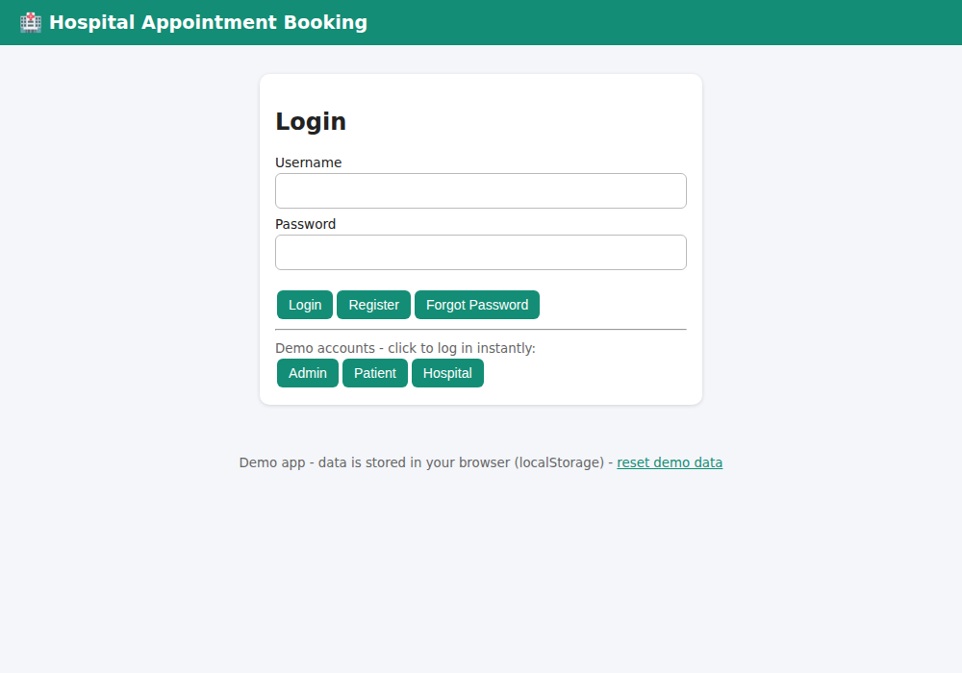
Figure 1: Login page with demo account buttons
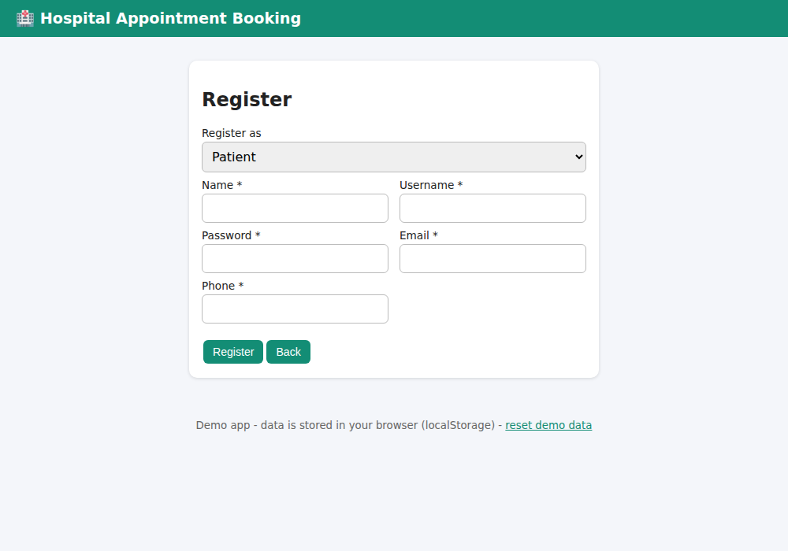
Figure 2: Registration page
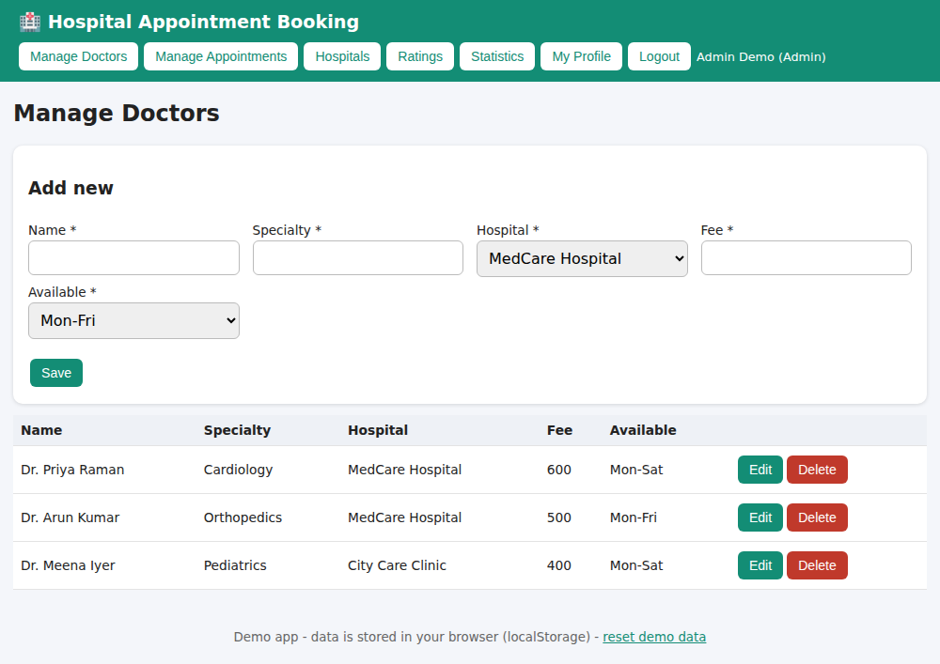
Figure 3: Admin - Manage Doctors
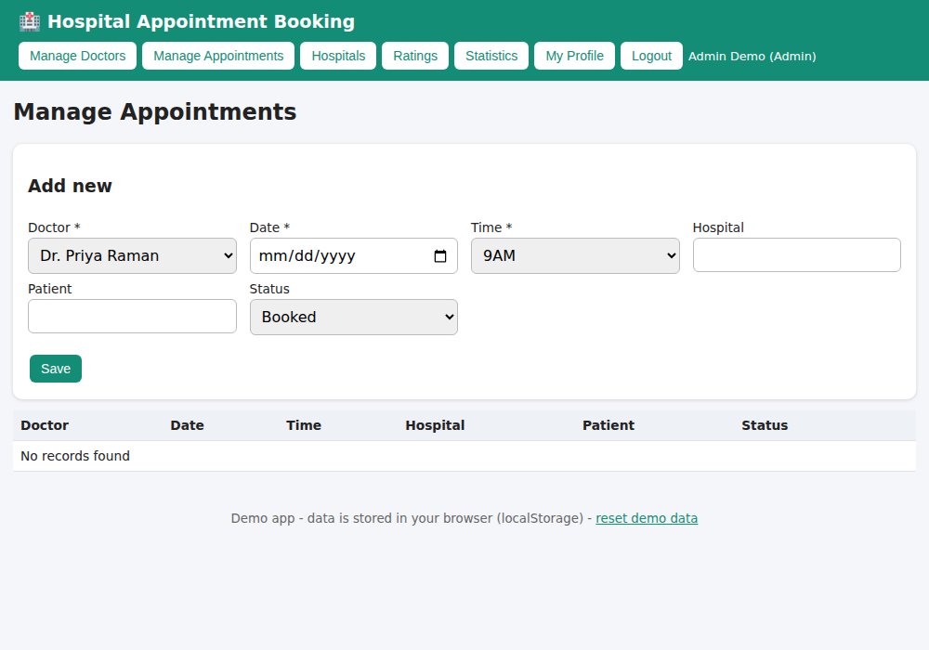
Figure 4: Admin - Manage Appointments
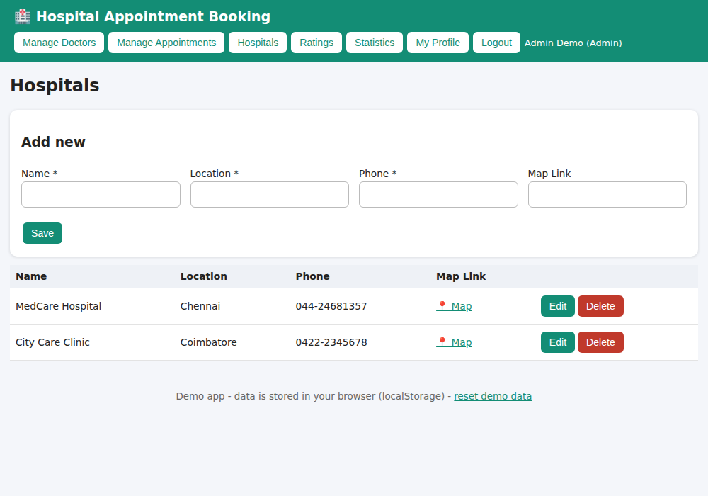
Figure 5: Admin - Hospitals
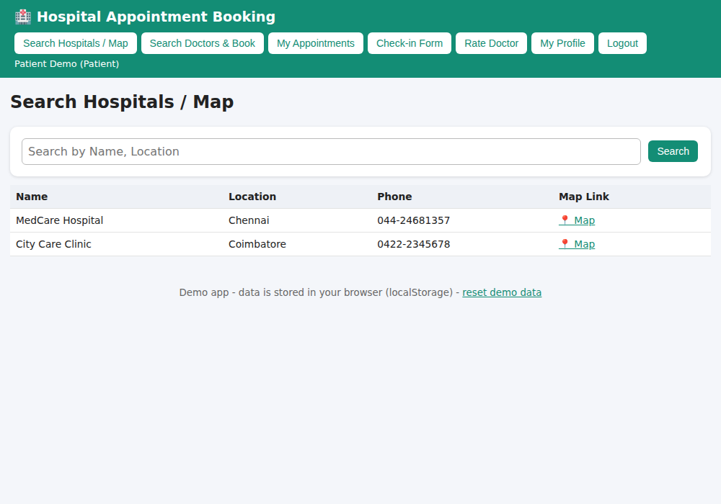
Figure 6: Patient - Search Hospitals / Map
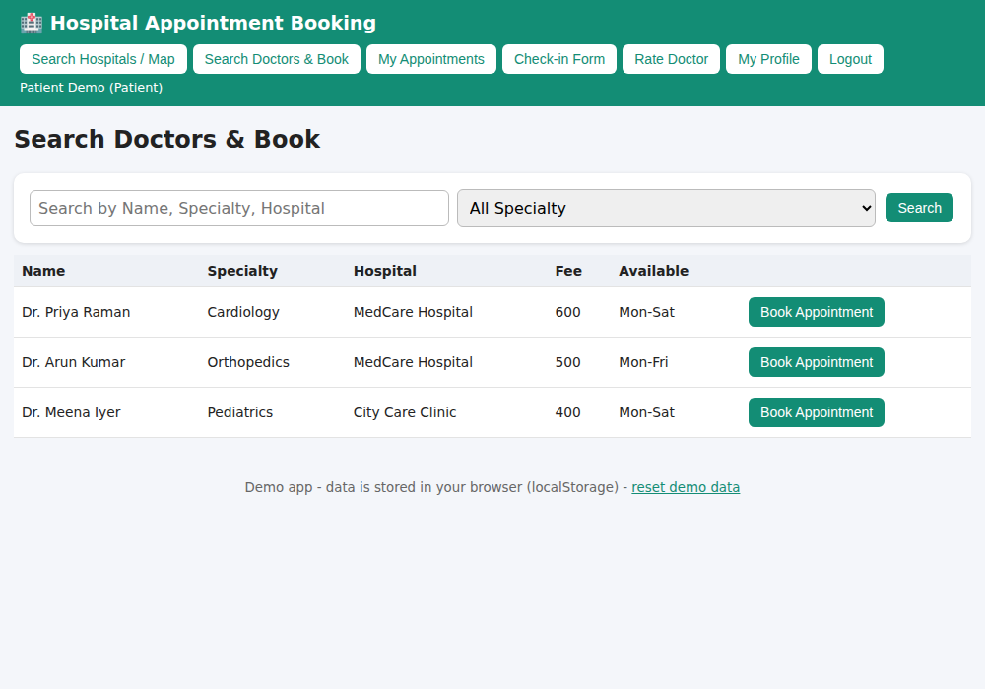
Figure 7: Patient - Search Doctors & Book
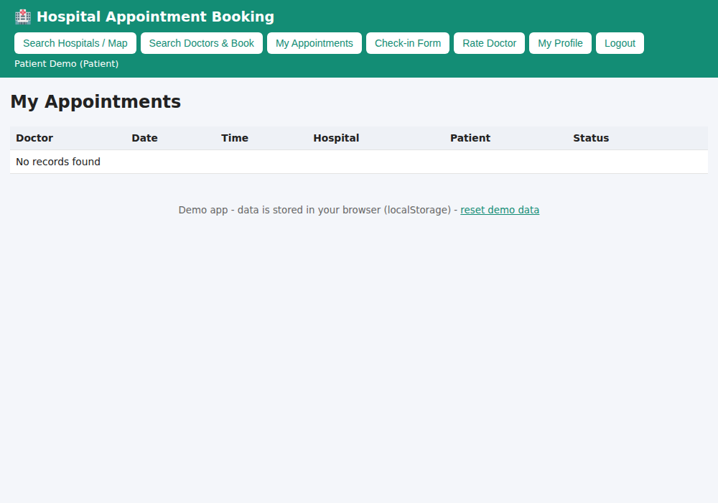
Figure 8: Patient - My Appointments
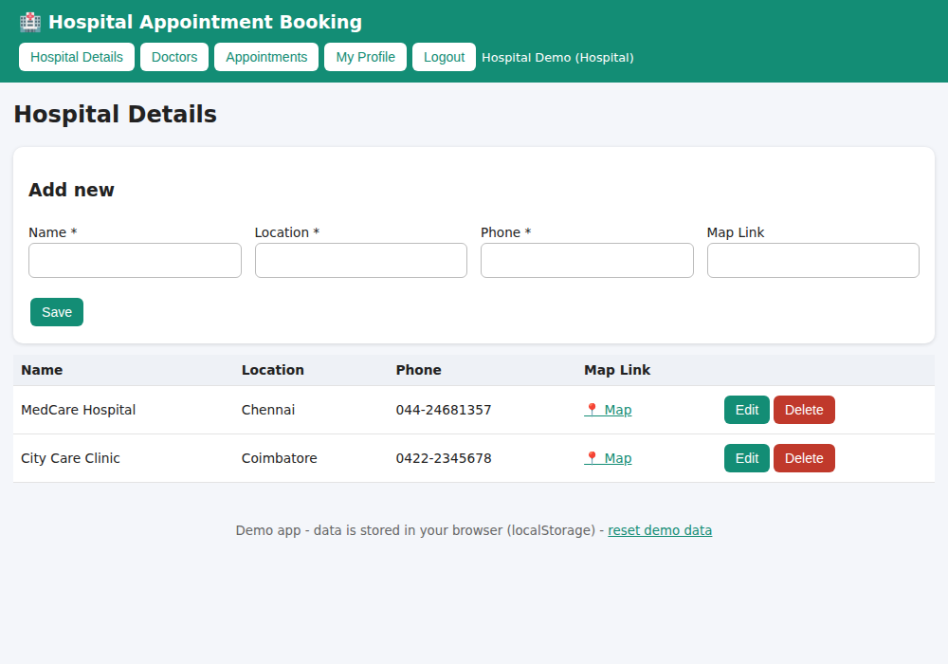
Figure 9: Hospital - Hospital Details
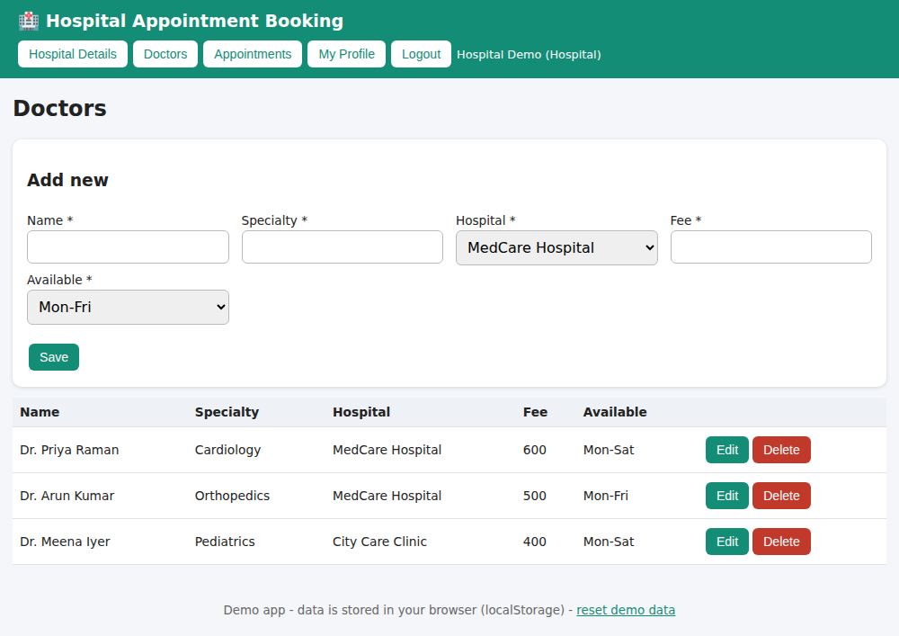
Figure 10: Hospital - Doctors
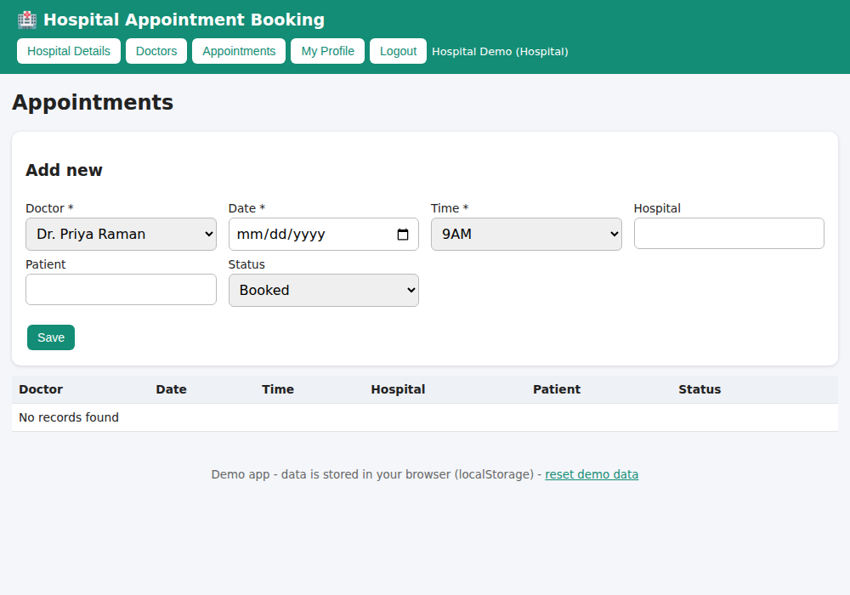
Figure 11: Hospital - Appointments
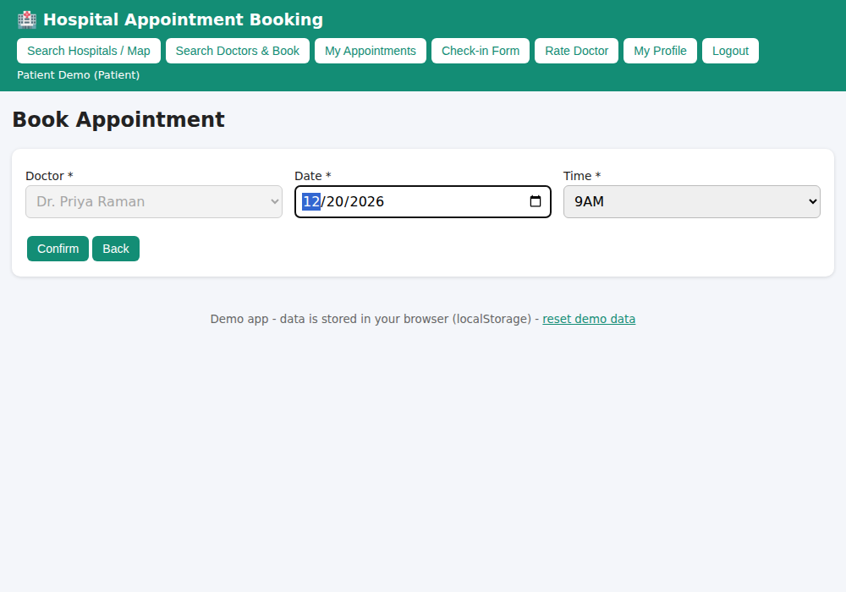
Figure 12: Patient - Book Appointment form (filled)
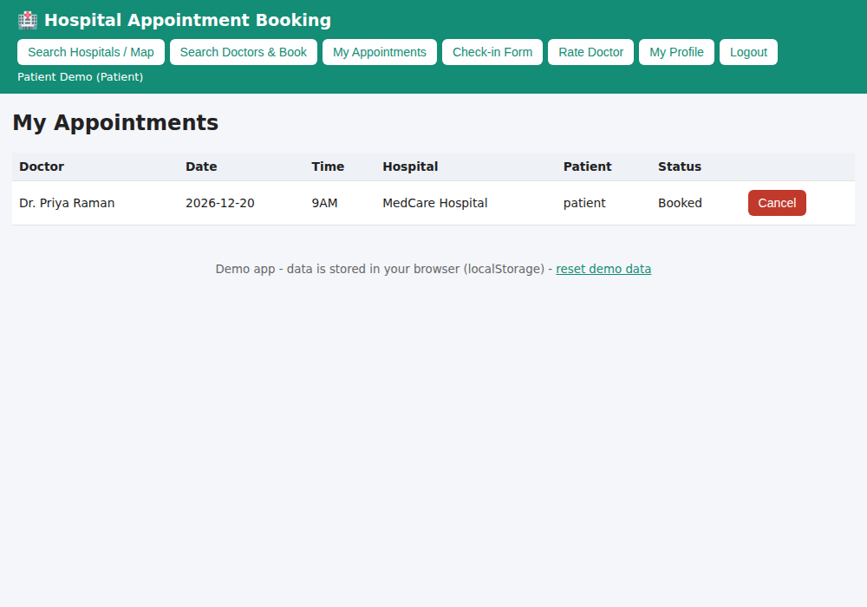
Figure 13: Patient - My Appointments (after Book Appointment)

Result
Thus the Hospital Appointment Booking web application was designed, implemented and executed successfully, and the output was verified for all user roles.

